iDoctor Medical System

A

Project Report

Submitted by

Viraj Shah

Jay Shah

Akash Sonetha

As the partial fulfillment of the requirement for the degree of Bachelor in Information Technology

Guided by

Prof. Kriti Srivastava

Prof. Michelle Dsouza



Department of Information Technology

D. J. Sanghvi College of Engineering,

Mumbai – 400056

Shri Vile Parle Kelvani Mandal’s

D. J. Sanghvi College of Engineering

Plot No U-15, Bhakti Vedanta Swami Marg, Juhu Scheme, Vile Parle(W), Mumbai-400056

CERTIFICATE

This is to certify that the following students have submitted the synopsis for the Project titled

**iDoctor Medical System**

At D. J. Sanghvi College of Engineering, Mumbai as a partial fulfillment of the requirement of the degree of Information Technology(Semester VIII) of University of Mumbai in the year 2012-2013

**Student Name Roll Number**

Jay Shah 60003090058

Viraj Shah 60003090064

Akash Sonetha 60003090069

Internal Guide

Prof. Kriti Srivastava

Prof. Michelle Dsouza

Internal Examiner External Examiner

Vice Principal (Acad) & HOD, IT Dept. Principal

(Prof. A. R. Joshi) (Dr. Hari Vasudevan)

**ACKNOWLEDGEMENT**

We thank the Management of the Dwarkadas J. Sanghvi College of Engineering and our respected Principal Dr. Hari Vasudevan for providing us with all the facilities to complete the project. We would like to convey our heartfelt gratitude to our Vice Principal Prof. Abhijit Joshi and our internal guide Prof. Kriti Srivastava for inspiring us to take up this project. Their valuable guidance and timely support, without which we would have never been able to complete the project, cannot be forgotten.

We would also like the opportunity to thank Prof. Michelle Dsouza for guiding us throughout the project.

Finally, we would like to express our gratitude to the faculty of Information Technology Department of Dwarkadas J. Sanghvi College of Engineering for their co-operation and timely assistance and our loved ones for their moral support.

**INDEX:**

1. Abstract
2. Literature Survey
3. Problem Definition with Scope and Objective
4. Project Plan
5. Your approach to solve the problem
6. Project Management
7. Schedule

* Task Network

1. Project Resources

* Hardware
* Software
* Special Resources

1. Estimation (any two methods)
2. Project Design
3. System Architecture (use generalized method)
4. Modules & Subsystems / CRC (Class Responsibility Collaboration)
5. Design Diagrams (OOAD or SSAD approach)

(If SSAD then DFD, CFD etc…)(If OOAD)

* Use Case
* Activity
* Class/Object

1. Data Design (If applicable)

* ER Diagram
* Tables

1. Interface Design

* User Interface
* Hardware Interface
* Software Interface
* Communication and Other Interfaces

1. Module/Component Description
2. Project Implementation
3. Project Testing
4. Test Plan
5. Test Cases
6. Methods Used
7. Test Results
8. Maintenance
9. User/Technical Manual
10. Constraints for use of product
11. Conclusion and Future Scope

References / Bibliography

**LIST OF TABLES:**

**TABLE PAGE NO**

Table 1: Coefficients for Basic COCOMO Model

Table 2: Estimation of Cost, Effort and Duration

Table 3: Project work breakdown structure

**LIST OF FIGURES PAGE NO.**

Figure 1: Block Diagram of Medical Supporting System

**Figure 2:**

**Figure 3:**

**Figure 4:**

**Figure 5:**

**Figure 6:**

**Figure 7:**

**Figure 8:**

**Figure 9:**

**Figure 10:**

1. **ABSTRACT:**

In today’s world where technology has progressed with the lightning speed, there is a need to create an electronic health platform, delivering 360-degree health services and products. IDoctor is an example of such a platform. Its deployment in the cloud and processing using data mining algorithm will prove really useful for those who seek to keep their health in check at the comfort of their home. This medical support system will help any user in getting a detailed report of their current health status and keep track of all the medicinal problems that have been faced by them as well as their other family members and use this data to generate a report using data mining algorithms. Therefore this system will not only save time in today’s hectic world but provide all round access to the service.

Our project aims at improving the medical assistance to patients in remote areas or for patients having no doctor or in case of emergency. It provides medical supporting system which registers patients and doctors. In case of emergency registered patients or unregistered patients are provided with medical helpline services depending on the severity of the problem the patient suffering from. It also includes online help for common questions asked by costumer or patients about their health life .As the this project is one of its type in India we try to explore this opportunity to enhance the medical system which in future may prove helpful for people of India specially people living in remote areas.

1. **Literature Survey**

We have gone through a variety of research papers, details of which are provided below:-

* **Wireless Sensing Systems in Clinical Environments.**

The Wireless sensing systems that automate some of the patient monitoring tasks can potentially improve the efficiency of patient workflows, but their efficacy in clinical settings is an open question. In this article, we introduce the challenges that such wireless sensing systems must overcome and provide insights on the techniques and features that system designers should consider for successful deployments in clinical settings. We do so through MEDiSN, a wireless sensor network (WSN) designed to continuously monitor the vital signs of ambulatory patients. We validate the usefulness of MEDiSN with test bed experiments and results from a pilot study performed at the Emergency Department, Johns Hopkins Hospital. Promising results indicate that MEDiSN can tolerate high degrees of human mobility, is well received by patients and staff members, and performs well in real clinical environments. We leverage our experience from this hospital pilot study to outline outstanding issues and argue about the steps necessary to bring wireless sensing applications to commercial use.

* **A Mobile Care System with Alert Mechanism.**

Hypertension and arrhythmia are chronic diseases, which can be effectively prevented and controlled only if the physiological parameters of the patient are constantly monitored, along with the full support of the health education and professional medical care. In this paper, a role-based intelligent mobile care system with alert mechanism in chronic care environment is proposed and implemented. The roles in our system include patients, physicians, nurses, and healthcare providers. Each of the roles represents a person that uses a mobile device such as a mobile phone to communicate with the server setup in the care center such that he or she can go around without restrictions. For commercial mobile phones with Bluetooth communication capability attached to chronic patients, we have developed physiological signal recognition algorithms that were implemented and built-in in the mobile phone without affecting its original communication functions. It is thus possible to integrate several front-end mobile care devices with Bluetooth communication capability to extract patients’ various physiological parameters [such as blood pressure, pulse, saturation of hemoglobin (SpO2), and electrocardiogram (ECG)], to monitor multiple physiological signals without space limit, and to upload important or abnormal physiological information to healthcare center for storage and analysis or transmit the information to physicians and healthcare providers for further processing. Thus, the physiological signal extraction devices only have to deal with signal extraction and wireless transmission. Since they do not have to do signal processing, their form factor can be further reduced to reach the goal of microminiaturization and power saving. An alert management mechanism has been included in back-end healthcare center to initiate various strategies for automatic emergency alerts after receiving emergency messages or after automatically recognizing emergency messages. Within the time intervals in system setting, according to the medical history of a specific patient, our prototype system can inform various healthcare providers in sequence to provide healthcare service with their reply to ensure the accuracy of alert information and the completeness of early warning notification to further improve the healthcare quality. In the end, with the testing results and performance evaluation of our implemented system prototype, we conclude that it is possible to set up a complete intelligent health care chain with mobile monitoring and healthcare service via the assistance of our system.

* **A Secure Mobile Healthcare System using Trust-Based Multicast Scheme.**

Due to the introduction of telecommunication technologies in telemedicine services, the expeditious development of wireless and mobile networks has stimulated wide applications of mobile electronic healthcare systems. However, security is an essential system requirement since many patients have privacy concerns when it comes to releasing their personal information over the open wireless channels. For this reason, this study discusses the characteristics and security issues with wireless and pervasive data communications for a ubiquitous and mobile healthcare system which consists of a number of mobile devices and sensors attached to a patient. These devices form a mobile ad hoc sensor network and collect data that are sent to a hospital or healthcare center for monitoring. Subsequently, this paper discusses the innovation and design of a novel trust evaluation model. We then propose a secure multicast strategy that employs trust in order to evaluate the behavior of each node, so that only trustworthy nodes are allowed to participate in communications, while the misbehavior of malicious nodes is effectively prevented. We analyze the security properties of our multicast scheme and evaluate its performance based on simulation experiments. Our experimental results demonstrate that our scheme not only achieves the necessary data transmission in mobile environments, but also provides more security with reasonably little additional overhead.

* **Monitoring Patients via a Secure and Mobile Healthcare System.**

Patient monitoring provides flexible and powerful patient surveillance through wearable devices at anytime and anywhere. The increasing feasibility and convenience of mobile healthcare has already introduced several significant challenges for healthcare providers, policy makers, hospitals, and patients. A major challenge is to provide round-the-clock healthcare services to those patients who require it via wearable wireless medical devices. Furthermore, many patients have privacy concerns when it comes to releasing their personal information over open wireless channels. As a consequence, one of the most important and challenging issues that healthcare providers must deal with is how to secure the personal information of patients and to eliminate their privacy concerns. In this article we present several techniques that can be used to monitor patients effectively and enhance the functionality of telemedicine systems, and discuss how current secure strategies can impede the attacks faced by wireless communications in healthcare systems and improve the security of mobile healthcare.

1. **Problem Definition with Scope and Objective**

Rural India contains over 68% of India's total population with half of it living below poverty line, struggling for better and easy access to health care and services. Our project aims at improving the medical assistance to patients in remote areas or for patients having no doctor or in case of emergency. It provides medical supporting system which registers patients and doctors. In case of emergency registered patients or unregistered patients are provided with medical helpline services depending on the severity of the problem the patient suffering from. It also includes online help for common questions asked by costumer or patients about their health life .As this project is one of its type in India we try to explore this opportunity to enhance the medical system which in future may prove helpful for people of India specially people living in remote areas.

Our objective is to design a complete medical supporting system in which we intend to cover following aspects:

* Provides website for unregistered patients
* Our system Registers patient’s data
* Provides Medical Service
* Contacts patients doctor

Provides a platform where patients can register to the system through the website. It registers patients’ complete information. It includes the basic information of the patient that is his name, address, mobile number etc. It also registers patient’s height, weight, family history, medical history of that patient, whether the patient has been victim of any major or minor disease or whether he has earlier undergone any operation. Also keeps a record of patient’s medical parameters like body temperature, heart rate, blood pressure etc. The details will get registered and a unique identity code will be given to each patient. The doctors can also avail the facility of registering. After the patient has registered, if he calls up the system through phone wherein his condition will be checked and in case of emergency he will be provided with the service and taken to the doctor available in the vicinity. If the patient calls the system in normal case, the system with one human representative will attend the patient. Here the patient’s required parameters will be measured .We intend to measure the essential parameters of the patients like Blood pressure, Heart rate,O2 level, temperature, Glucose level. Once the patients report is generated containing its parameter and patient details, it is sent to the patient’s doctor for further diagnosis. Now on diagnosis depending on the level of emergency either immediate remedy is suggested or appointment with doctor is fixed, if the injury or disease is severe patient is taken to the doctor nearby.

The measured parameters will be used to generate a report for the patient who will be sent to the family doctor or any Available doctor in the vicinity. The doctor will then provide the diagnosis after studying the patient history and his current health condition. Depending upon the number and the location of the registered members, the service can be made available in different parts of the country. In an age where work is the top most priority for an individual, such a system would help in looking after the health of an individual and taking care of his well-being.

1. **Project Plan**
2. **Project Management**
3. **Schedule**

* **Task network**

1. **Project Resources**
2. **Hardware:**

* Parameter measuring circuits
* **USB of type To-B**
* A Computer with 1 GB RAM and DUAL Core Processor

1. **Software:**

* Arduiono 1.0.1
* Net beans 6.8 or higher
* Java 1.6
* HTML
* CSS
* PHP
* Ajax

1. **Web Browser:**

* Internet Explorer 5.5 and higher
* Firefox 1.5 and higher
* Google Chrome 22.0.0.0 or higher

1. **Estimation:**
2. **Estimation Method-COCOMO:**

**Historical data used for the estimation:**

While making estimations about various factors like efforts involved, the number of people required finishing the project and also the duration required for the completion of the project we took under consideration various factors such as follows:

1. We first determined the characteristics of our project depending on various factors like the size of our project, innovations, development environment etc.
2. Depending on the characteristics of our project we also determined the development mode of the project. This mode will help us n determining various constants which will be used further during estimation.
3. We approximated the number of kilo lines of code which is useful during estimation.

Estimation Technique:

The estimation technique used is COCOMO

The Constructive Cost Model (COCOMO) is an algorithmic software cost estimation model. The model uses a basic regression formula with parameters that are derived from historical project data and current project characteristics.

Basic COCOMO computes software development effort (and cost) as a function of program size. Program size is expressed in estimated thousands of lines of code (KLOC)..

COCOMO applies to three classes of software projects:

1. Organic projects-“small” teams with “good” experience working “with less than rigid” requirements.
2. Semi-detached projects-“medium” teams with mixed experience working with a mix of rigid and less than rigid requirements.
3. Embedded projects-developed within a set of “tight” constraints(hardware, software, operational, etc)

The basic COCOMO equations take the form

Effort Applied =ab(KLOC)bb [man-months]

Development Time=cb(Effort Applied)db [months]

People Required=Effort Applied/Development Time [count]

The coefficients ab, bb, cb, db are given in the following table.

|  |  |  |  |  |
| --- | --- | --- | --- | --- |
| Software project | ab | bb | cb | db |
| Organic | 2.4 | 1.05 | 2.5 | 0.38 |
| Semi-detached | 3.0 | 1.12 | 2.5 | 0.35 |
| Embedded | 3.6 | 1.20 | 2.5 | 0.32 |

Table 1: Coefficients for Basic COCOMO Model

Basic COCOMO is good for quick estimate of software costs. However it does not account for differenced in hardware constraints, personnel quality and experience ,use of modern tools and techniques and so on.

**Estimate of Cost, Effort and Duration**

**-**According to the explanation given above, our project will be of type embedded since it will be developed under time, software and hardware constraints.

Therefore we will take ab=3.6,bb=1.2,cb=2.5,db=0.32

-Using the above values we will calculate the following:

Effort Applied =ab(KLOC)^bb

=3.6(4)^1.20

=16.19

Development Time=cb(Effort Applied)^db

=2.5(24.411)^0.32

=6.09=6 months

People Required=Effort Applied/Development Time

=16.19/6.09

=2.66=3 people

Thus according to cocomo model we get the following result

|  |  |
| --- | --- |
| Effort Applied | 16 [man-month] |
| Development Time | 6 months |
| People Required | 3 |

Table 2: Estimation of Cost, Effort and Duration

1. **Timeline Chart**

**Project work breakdown structure**

|  |  |
| --- | --- |
| WORK TASK | DESCRIPTION |
| **1** | **INCEPTION PHASE** |
| 1.1 | Study working Arduiono system and their architecture |
| 1.2 | Choosing a method for implementation and algorithms to be used |
| 1.2.1 | Procuring technical papers and other research materials about these techniques |
| 1.2.2 | Study and discussion of these methods. |
| 1.3 | Problem definition, Scope and Feasibility study |
| 1.3.1 | Defining the problem |
| 1.3.2 | Fixing the scope of the project |
| 1.3.3 | Feasibility analysis |
| 1.4 | Requirement analysis |
| 1.5 | Project Estimation |
| **2** | **ELABORATION PHASE** |
| 2.1 | Algorithm design |
| 2.1.1 | Development of diagnostic algorithm |
| 2.1.2 | Development of other algorithms |
| 2.2 | UML Diagrams |
| 2.2.1 | Use case diagram |
| 2.2.2 | Activity diagram |
| 2.2.3 | Class diagram |
| 2.2.4 | Sequence and collaboration diagram |
| 2.2.5 | State transition diagram |
| **3** | **CONSTRUCTION PHASE** |
| 3.1 | Implementing the algorithms |
| **4** | **TESTING PHASE** |
| 4.1 | Unit Testing |
| 4.2 | Integration testing |
| 4.3 | System testing |
| **5** | PROJECT DEPLOYEMENT |
| **6** | DOCUMENTATION |

Table 3: Project work breakdown structure

1. **Project Design**

In this book we present the idea to design a health service, which is just a click away of a button – online or a phone call. All the services are at provided to the doorstep. In this jet age, these services are specially designed to be convenient and to save your time. This medical supporting system provides a platform where a patient can register with the system first. It provides medical service to the registered patient as well as unregistered. This system provides required medical service in case of emergency. The patient can access the system through website also. The Website provides the user with a whole lot of options and remedies based on his history and current situation. In case of an emergency the registered Doctor is notified about the patient’s situation via an SMS and/or a Mail.

1. **System Architecture:**
2. **Block Diagram of Medical Supporting System**

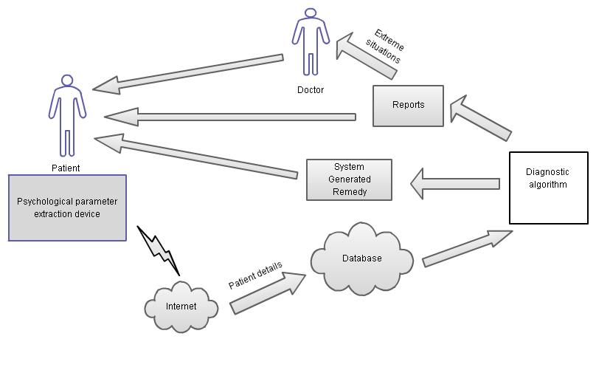

Figure 1: Block Diagram of Medical Supporting System

Our objective is to design a complete medical supporting system in which we intend to cover following aspects:

* Provides website for unregistered patients
* Our system Registers patient’s data
* Provides Medical Service
* Contacts patients doctor

Provides a platform where patients can register to the system through the website. It registers patients’ complete information. It includes the basic information of the patient that is his name, address, mobile number etc. It also registers patient’s height, weight, family history, medical history of that patient, whether the patient has been victim of any major or minor disease or whether he has earlier undergone any operation. Also keeps a record of patient’s medical parameters like body temperature, heart rate, blood pressure etc. The details will get registered and a unique identity code will be given to each patient. The doctors can also avail the facility of registering. After the patient has registered, if he calls up the system through phone wherein his condition will be checked and in case of emergency he will be provided with the service and taken to the doctor available in the vicinity. If the patient calls the system in normal case, the system with one human representative will attend the patient. Here the patient’s required parameters will be measured .We intend to measure the essential parameters of the patients like Blood pressure, Heart rate,O2 level, temperature, Glucose level. Once the patients report is generated containing its parameter and patient details, it is sent to the patient’s doctor for further diagnosis.

1. **Modules and Subsystems**

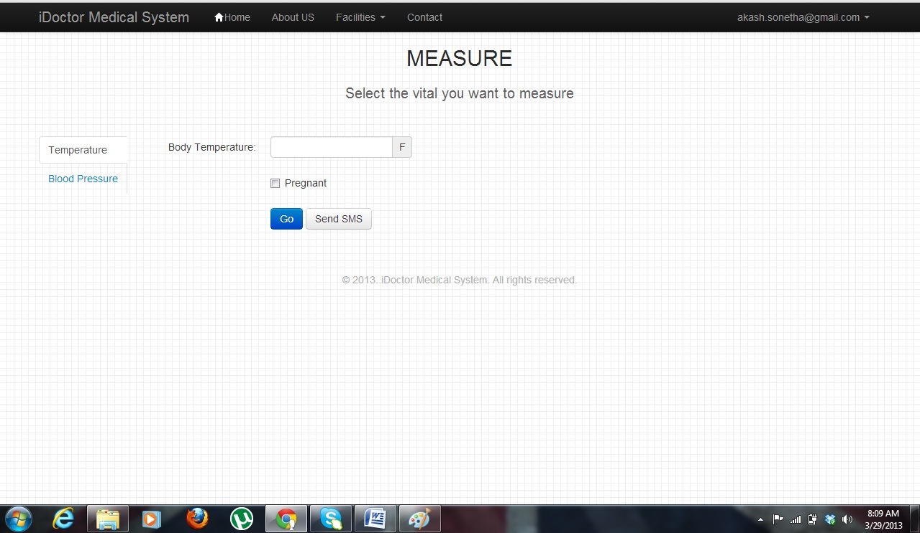

**Figure 2: Snapshot of Measuring Vitals Interface**

This is the block diagram of the parameters to be measured which include body temperature; the output of the sensor goes through amplifier and filter circuit and after signal conditioning it’s given for digitization and the value is then fed into the laptop/computer via usb connector. Other parameter is blood pressure the output from the digital blood pressure is fed into the laptop via usb, similarly the oximeter output from the probe is connected to the usb connector an and is fed into the computer /laptop. In the end is the Glucose level which will feed the sugar level of the patient.

**Patient Report:**

1. **Design Diagrams**
2. **Use Case Diagram:**

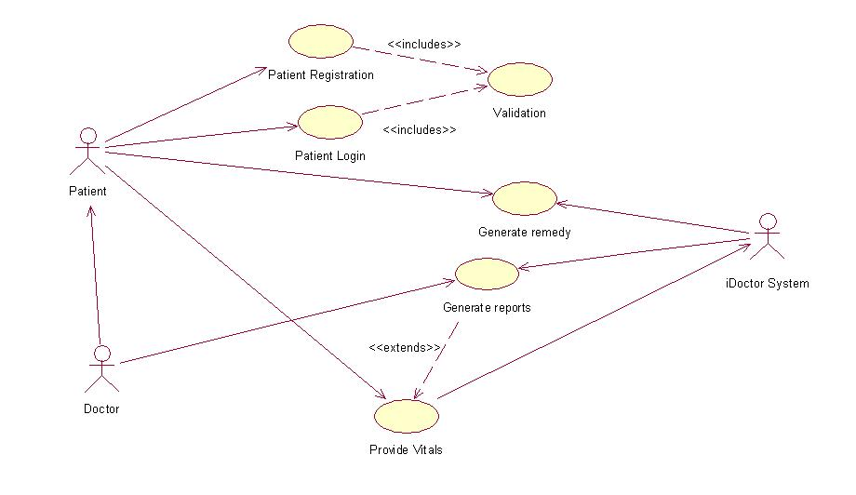

**Figure 3: Use Case Diagram**

1. **Activity Diagram:**

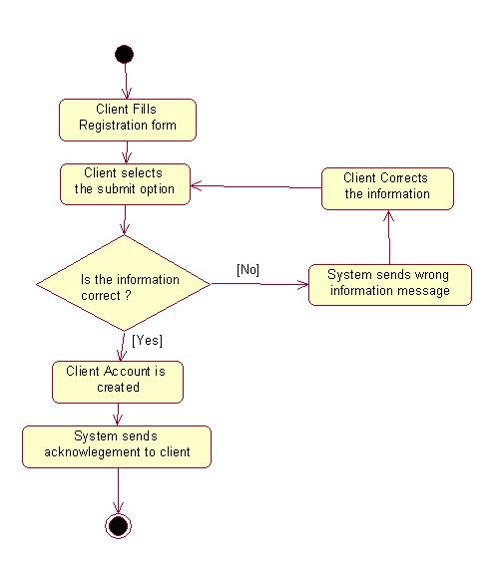

**Figure 4: Sequence Diagram**

1. **Class Diagram:**

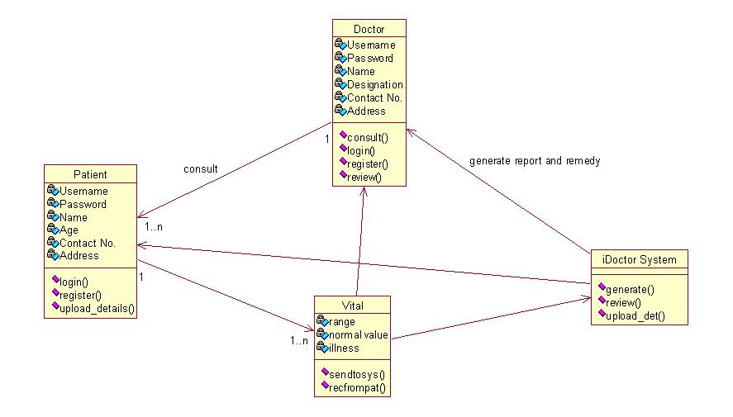

**Figure 5: Class Diagram**

1. **Data Design**
2. **ER Diagram**
3. **Tables**
4. **Interface Design**
5. **User Interface**

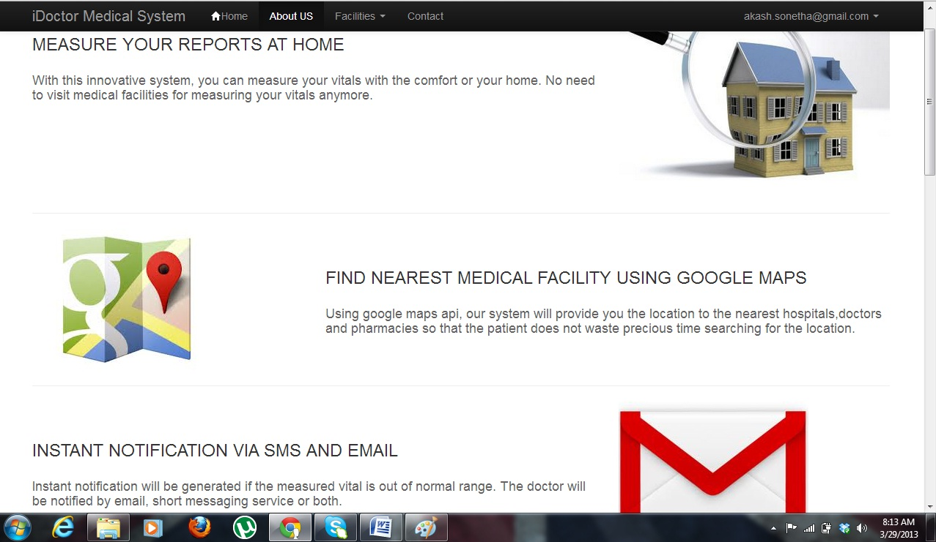

**Figure 6: Snapshot Homepage**

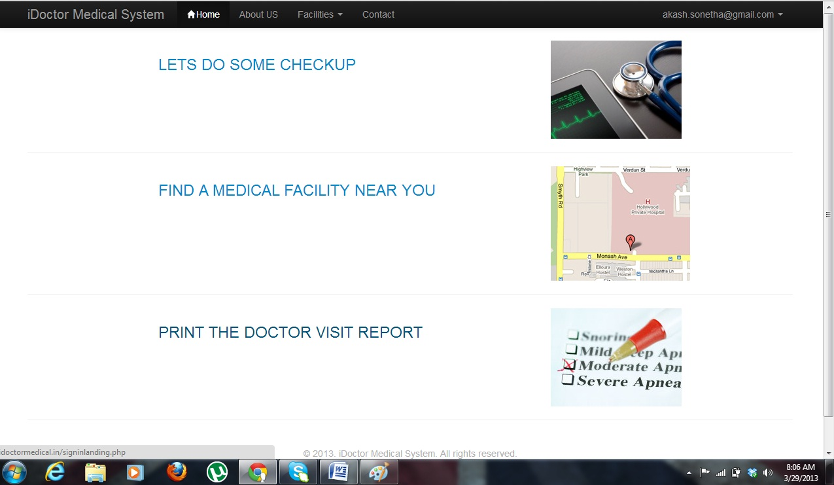

**Figure 7: Snapshot Facilities**

1. **Project Implementation**

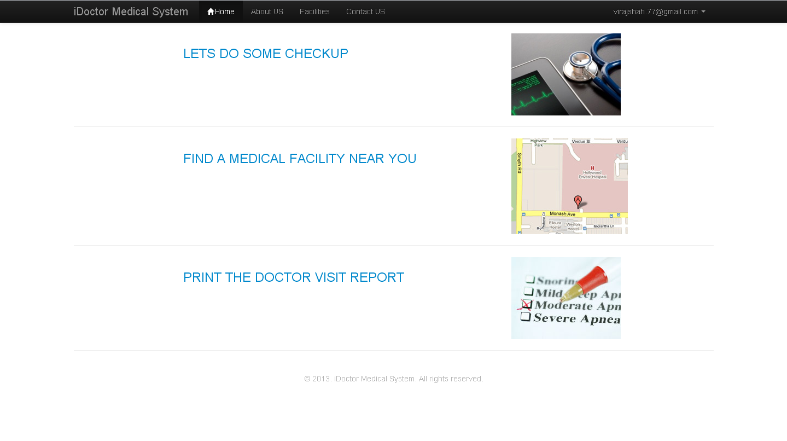

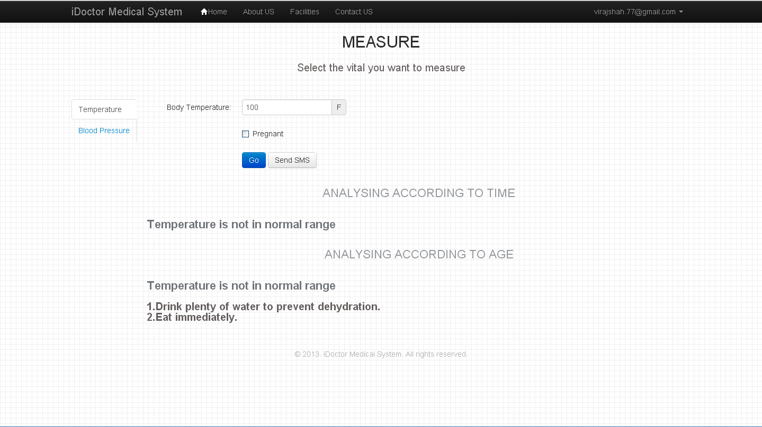

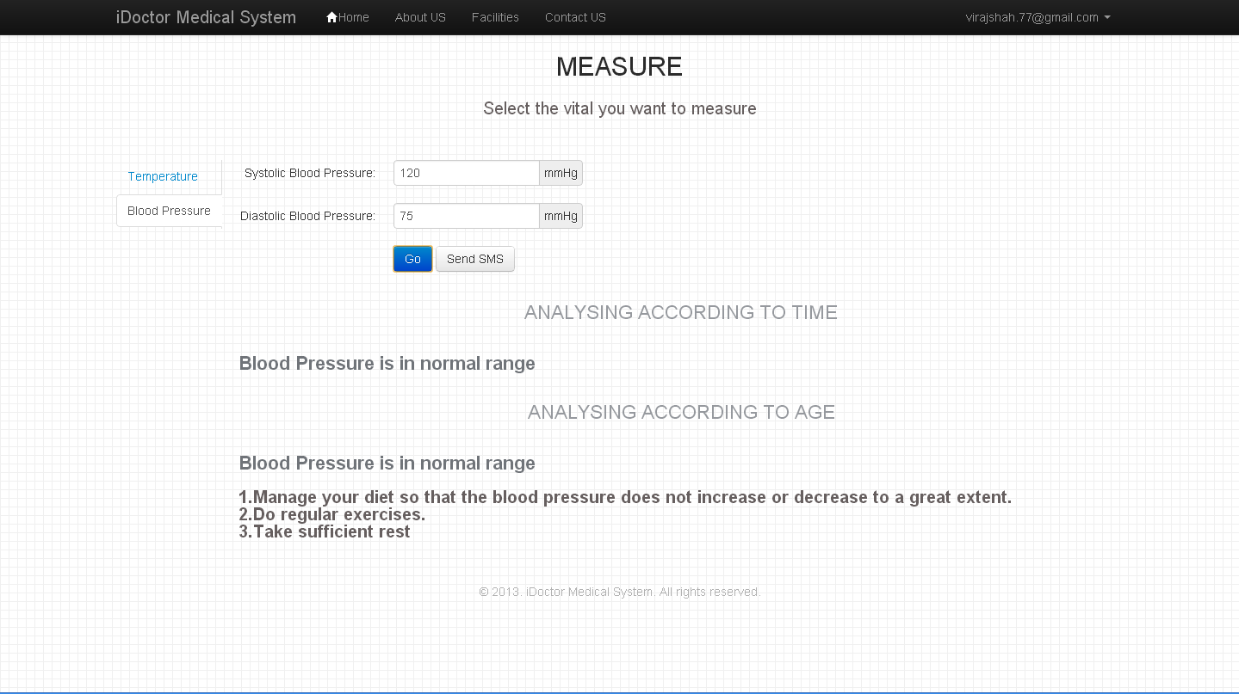

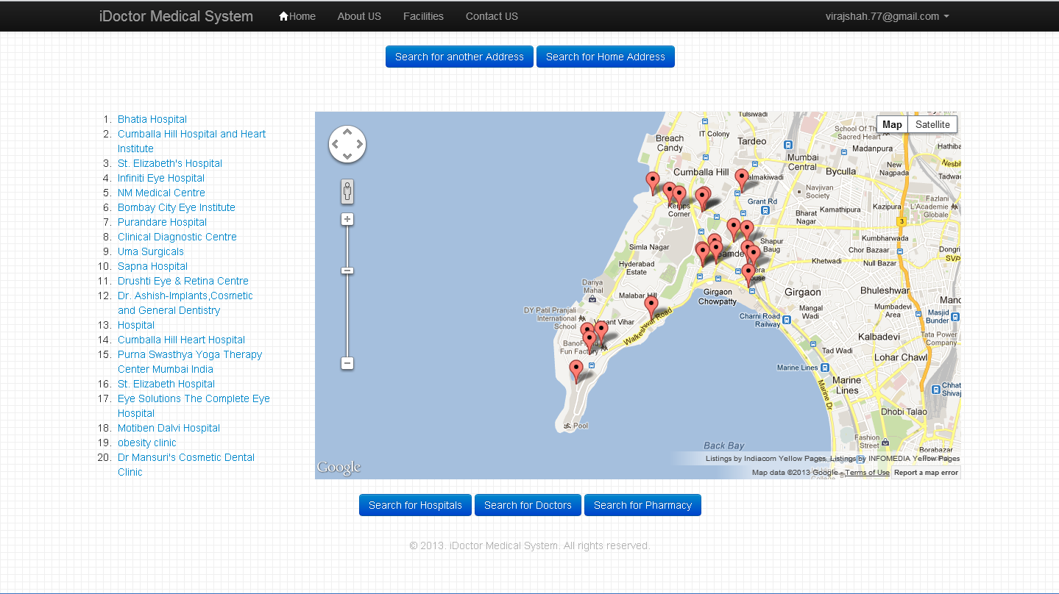

**Figure 8: Snapshot Map Description 1**

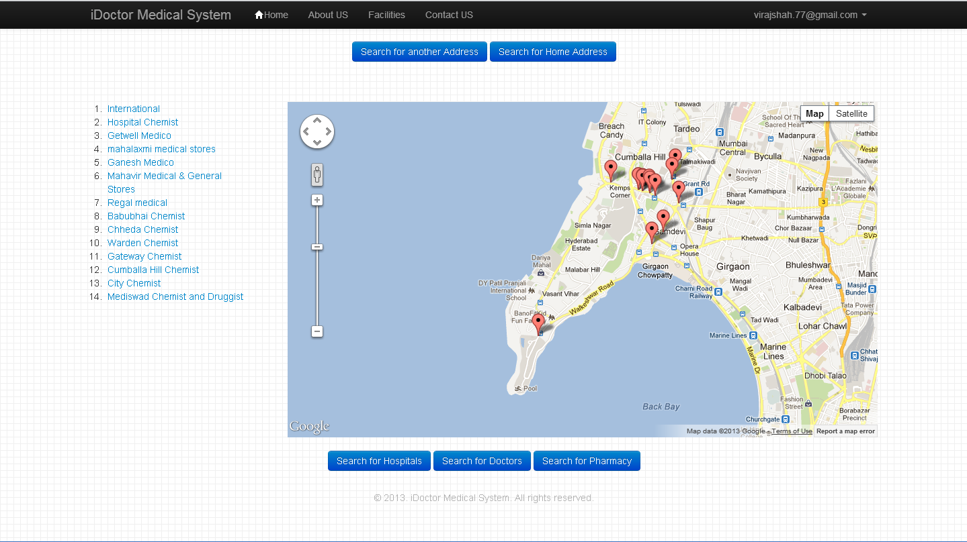

**Figure 9: Snapshot Map Description 2**

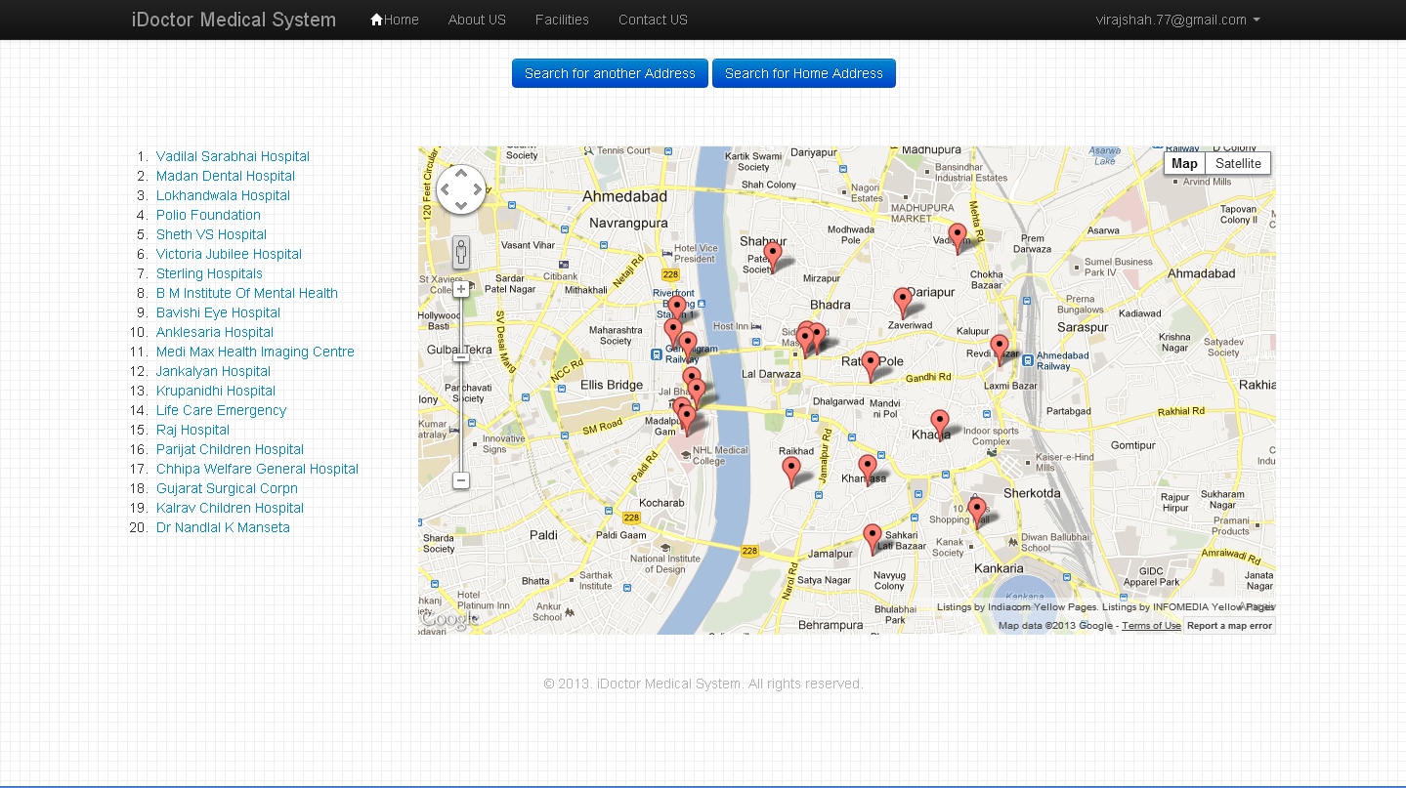

**Figure 10: Snapshot Map Description 3**

1. **Project Testing**
2. **Test Plans**

The test plan approach that has been used in our project includes the following:

* Design verification or Compliance test:

These Stages of testing have been performed during the development or approval stage of the product, typically on a small sample of units.

* Test Coverage:

The design verification tests have been performed at the point of reaching every milestone. Test areas included testing of various services dividing each service into a module and then later integrating all the modules.

* Test Methods:

Testing of diverse features has been performed in “iDoctorMedical.in”. For each module, corresponding outputs were checked. For testing each module, the output produced from running the code was checked with the test data set.

* Test Responsibility:

The team members working on their respective features performed the testing of those features. Test responsibilities also included, the data collected, and how that data was used and reported.

1. **Test Cases**
2. **Methods Used**

* UNIT TESTING

Unit testing is a method by which individual units of [source code](http://en.wikipedia.org/wiki/Source_code), sets of one or more program modules together with associated control data, usage procedures, and operating procedures, are tested to determine if they are fit for use. In our tool, we considered each module as one unit and tested these units with help of test cases and test plan developed. Unit testing was carried out on each module and on every function within the module. Output of each unit was assessed for accuracy and if found incorrect, appropriate corrections were made.

* INTEGRATION TESTING

Integration testing is the phase in [software testing](http://en.wikipedia.org/wiki/Software_testing) in which individual software modules are combined and tested as a group. The various modules were tested together to check for their accuracy and compatibility. After each unit functioning properly we bought all these units together and made it a single web-service.

1. **Test Results**

* Testing has successfully been carried out and the web service is now ready to be launched without any error.

1. **Maintenance:**
2. **User / Technical Manual**
3. **Constraints for use of Project**
4. **Conclusion and Future Scope:**

The concept of measuring patient parameters with the help of a call service is one of its first kinds in the country. The aim is to provide service to the people who don’t have a family or are in the state of an emergency.

The measured parameters will be used to generate a report for the patient who will be sent to the family doctor or any Available doctor in the vicinity. The doctor will then provide the diagnosis after studying the patient history and his current health condition. Depending upon the number and the location of the registered members, the service can be made available in different parts of the country. In an age where work is the top most priority for an individual, such a system would help in looking after the health of an individual and taking care of his well-being.

**References / Bibliography:**